I was unable to capture screenshots directly from my Ubuntu VirtualBox environment on Mac due to technical limitations with the screenshot functionality. As an alternative, I've attached photographs of the outputs taken with my phone. Hope you will consider this.

Task1 output:

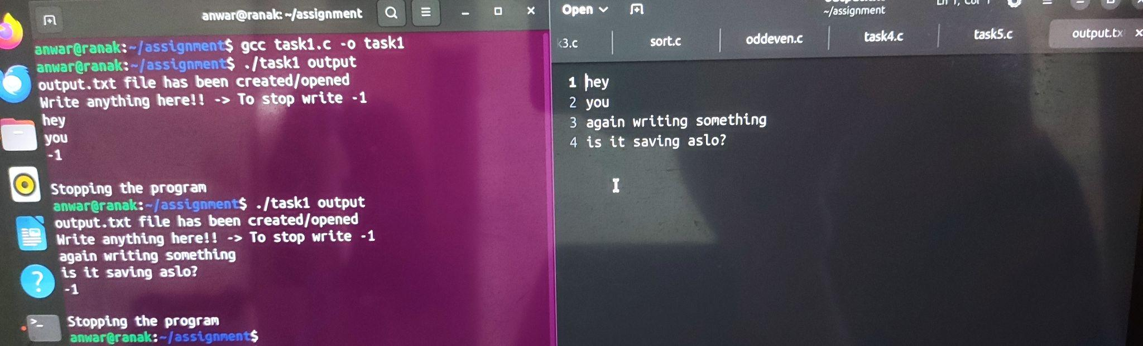

Task2 output:

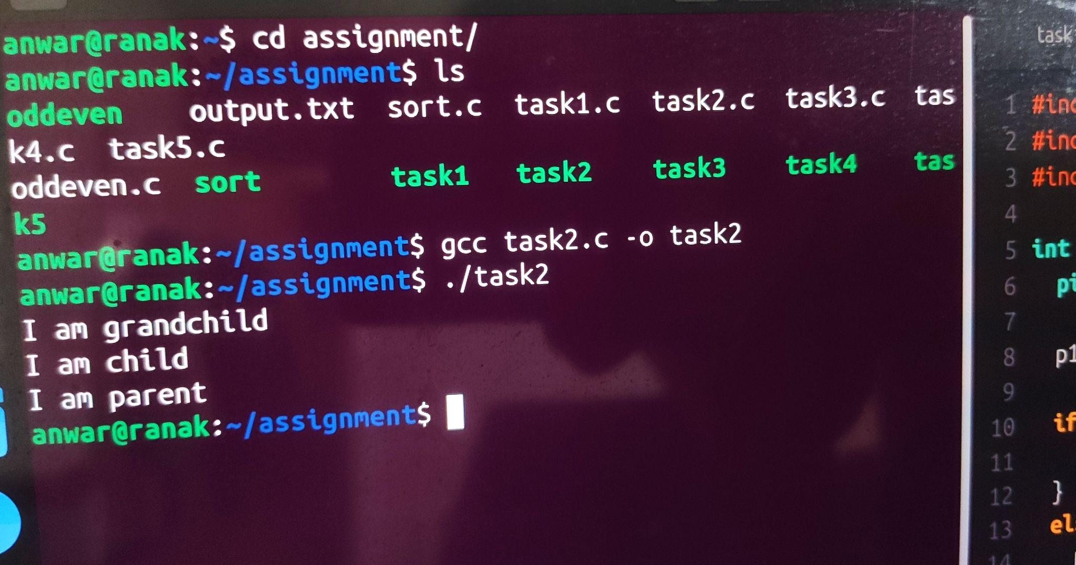

Task3 output:

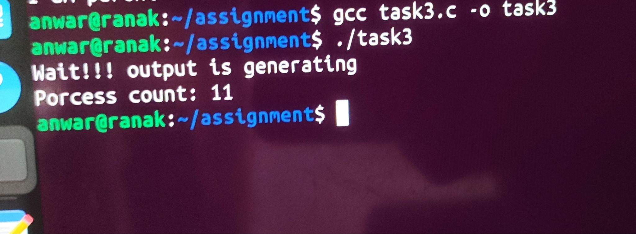

Task4 output:

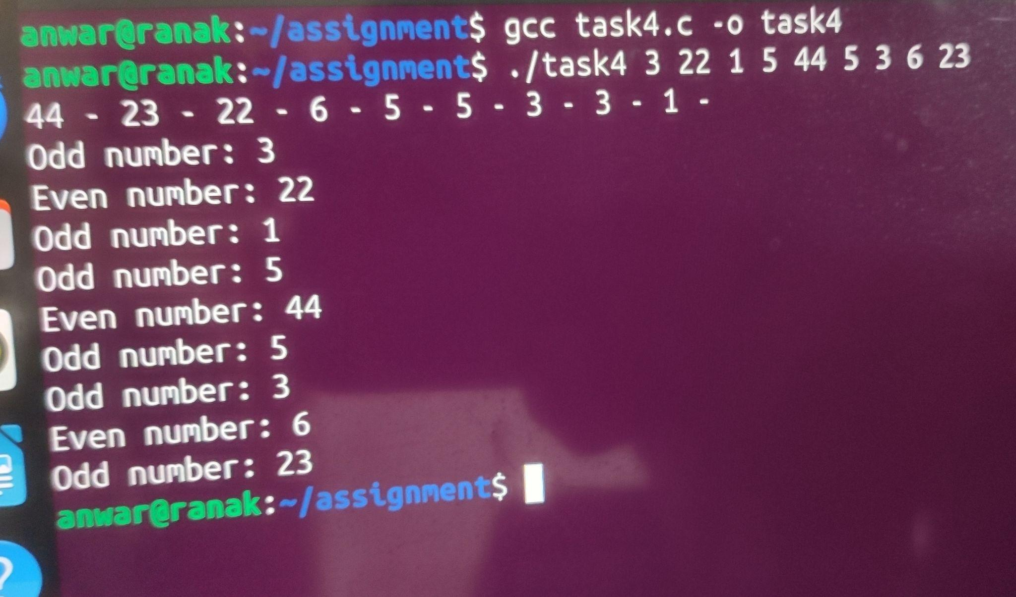

Task5 output:

